EDHR Stop Search Report
2018/19 (April 2018 to March 2019)
MEETING | EQUALITY, DIVERSITY AND HUMAN RIGHTS BOARD
SUBJECT | STOP SEARCH YEAR TO DATE PERFORMANCE
PORTFOLIO LEAD | ACC VAUGHAN, OPERATIONAL SUPPORT
REPORT BY | ---- (PERFORMANCE ANALYST)
SUMMARY AND PURPOSE OF REPORT

To provide a brief update on stop searches recorded between April 2018 and March 2019.

Executive Summary
The force has recorded 58% more stop searches financial year 2018/19 (10,555 searches) compared to the same period in 2017-18 (6,671 searches).
- The number of individuals stop searched has risen by 50% from 5,086 to 7,645.
- Persons with a Black self-defined ethnicity are just over 6 times more likely to be stop and searched than White persons.
- 73% of white people stop searched had a pre-existing PNC ID compared to nearly 70% of BME persons.
- 82% of officers, who conducted a stop search, carried out more than one stop search in the timeframe.
- The most any one member of the public was stop searched was 19 times in the period.
- An officer carried out 232 Stop Searches during the financial year 2018/19 with another officer following behind with 101 stop searches. Please note that the 232 stop searches related to 191 individuals by an officer in Central NPT.

2. Introduction
This report provides a summary of recorded stop search information for the financial period April 2018 to March 2019, focusing on key issues of quality assurance and disproportionality. The process of assessing the volume and impact of stop searches remains complex although work is ongoing to improve the mobile and Niche recording of stop searches.

Data Quality and Compliance

3.1 Data Quality Issues
Newer versions of the mobile app are still showing continuing signs of data quality issues for the following reasons:

- The manual LIO/Supervisor processes (required for those stop searches where the individual stop searched is not on Niche and/or where locations are not on the gazetteer) are still in the process of being fully implemented across the force area. The introduction of the new app appears to have made this more of an issue.

- Technical issues with the gazetteer result in missing location data unless manual intervention is undertaken.

- Various assumptions are made within the data, primarily that the Unit recorded on NICHE is accurate. This is used as a gauge of where a Stop Search has been completed.

.

Figure 2 Stop Searches and Data Quality
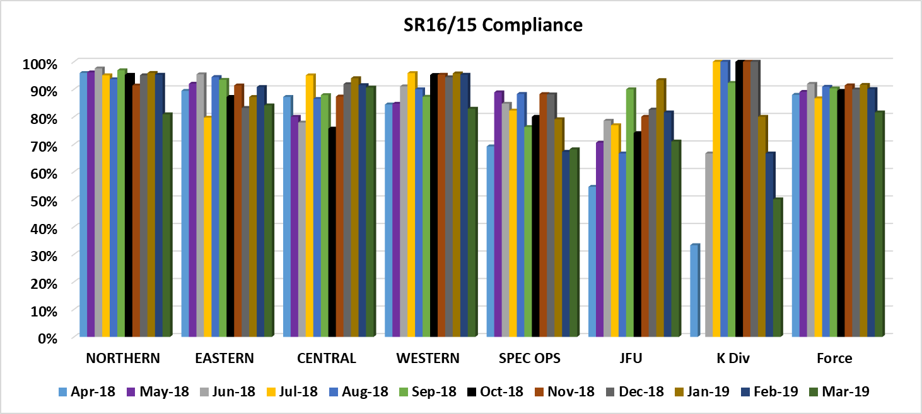

Please note that where a supervisor checks a stop search record, this means that the record is now compliant. Initially the stop search record could have been given the SR15 on the first review by the supervisor or it could have been given an SR16 – Unsatisfactory status initially and then given an SR15-Satisfactory status once, the officer had addressed the supervisor’s comments. With the above in mind, the following table demonstrates the breakdown in terms of the volume of Desktop Occurrences submitted and the relative SR16/15 Compliance rates.

4. Stop Search Analysis
  - Stop Search Trends

The volume of stop searches is not a performance indicator and should be seen as a reflection of operational activity and intelligence led policing. The force has seen a decline in the number of stop searches over the past few years; however, the force has recorded 58% more stop searches in April 18 to March 19 (10,555 searches) compared to the same period in 2017-18 (6,671 searches).

Given the above please see the below chart which shows trends over time:
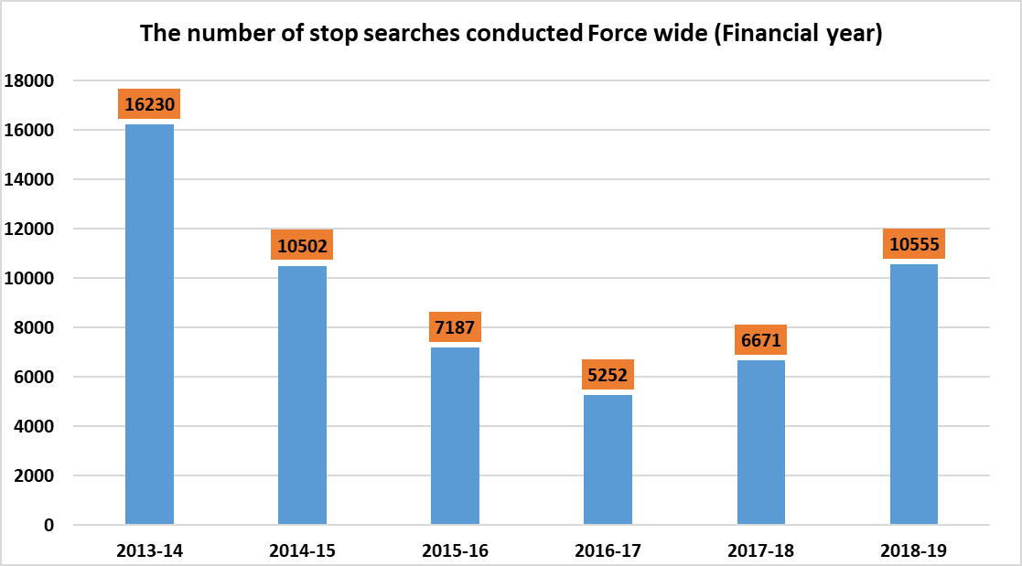

Further analysis shows that the number of individuals stop searched has risen by 33% from 5,085 to 7,645. This figure however relates to unique Niche IDs.

Figure 5 shows the proportion of stop searches compared to their associated outcomes over time. We can see that the majority of outcomes are “NFA” although the proportion of “other positive” outcomes and the number of arrests has improved. This can be attributed to an increase in the outcome, “Community resolution”, the number of “charged/Summons” and “Drug warnings”. The YTD picture shows a rise in the percentage of positive outcomes and this can again mainly be attributed to Northern BCU.

Figure 5 Stop Search Volume and Proportion by Outcome
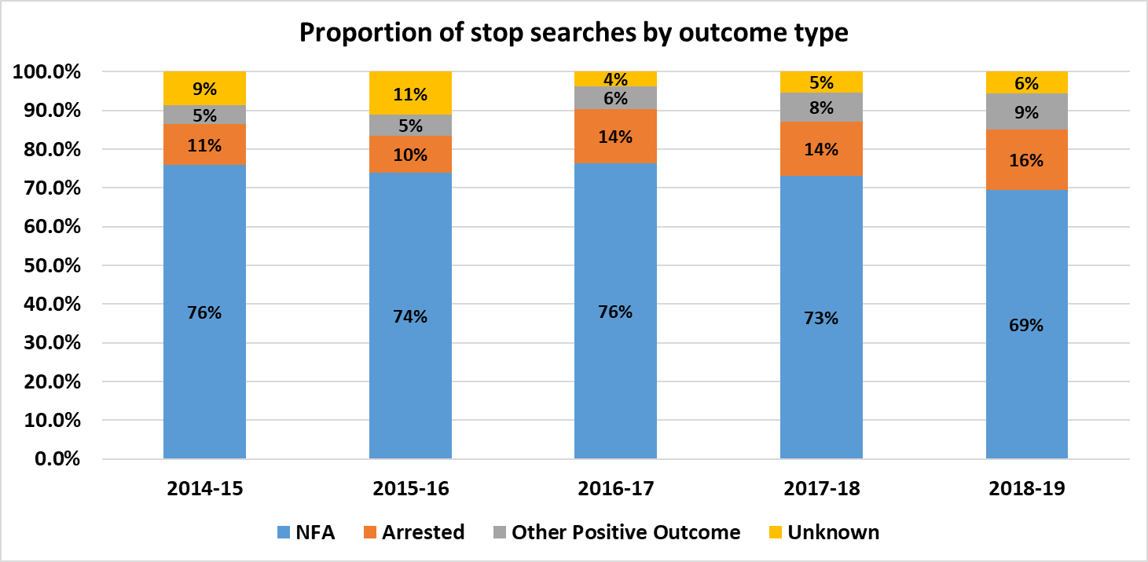
The following chart shows highly variable trends by BCU of stop search over time.

Figure 6 Stop Search by Month and Stop Search Location

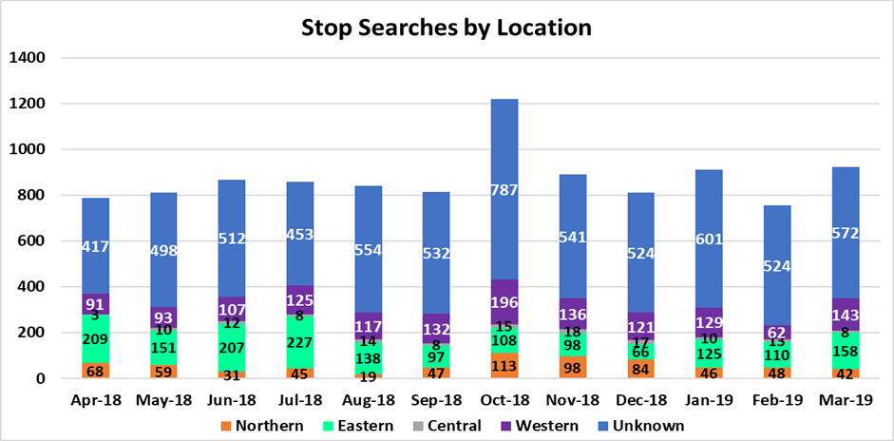

Figure 7 shows the volume of stop searches by Officers’ designated BCUs as opposed to their recorded Stop Search Location (as shown by figure 6). Eastern accounts for the highest volume, with Western being the second highest.

Figure 7 Stop Searches by Officer BCU
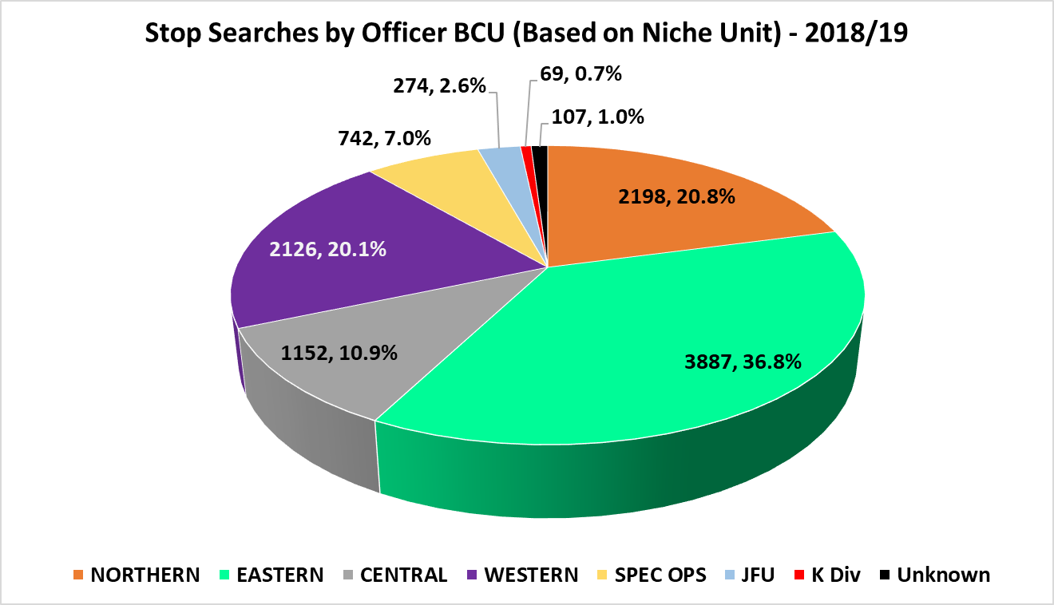

4.2 Stop Searches – Ethnicity
Figure 8 shows that a member of the black community was just over 6 times more likely to be stop searched during financial year 2018-19 than a white person. However, the volume of Black stop searches remains very low (536, 5% of all stop searches in the timeframe). The ethnic population figures are based on the ethnic proportions from the 2011 Census applied to the population data in mid-year 2016.

During 2018/19, 1,281 Stop Searches conducted against BME persons accounted for 12% of the total stop searches for the period. In total, 1,281 BME individuals were stop searched which also made up 13% of individuals stop searched.

During the financial year in terms of the number of people stop searched, 17% of BME individuals were stop searched more than once in the timeframe compared to 20% for white individuals.

Figure 8 Stop Searches per 1000 population

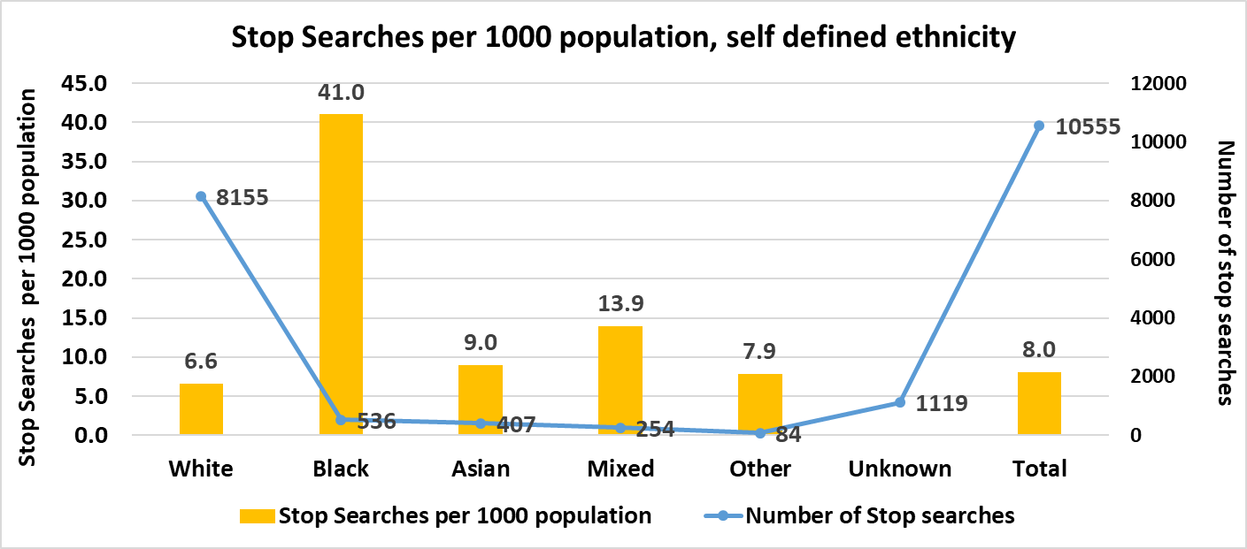

Using the existence of a PNC ID as a proxy for intelligence led stop searches (i.e., where the individual is known to have committed a previous crime), analysis shows that this proportion was fairly similar, with 73% of White persons having a PNC ID, 70% of BME persons.

Figure 9 below for financial year 2018/19, shows that there are similar proportions of NFA outcomes for people of black, Asian and mixed ethnicity compared to white people, however, as numbers are very small, this should be interpreted carefully.

Please see the below for stop searches per 1000 population during the previous financial years:

Figure 8a Stop Searches per 1000 population, 2017/18
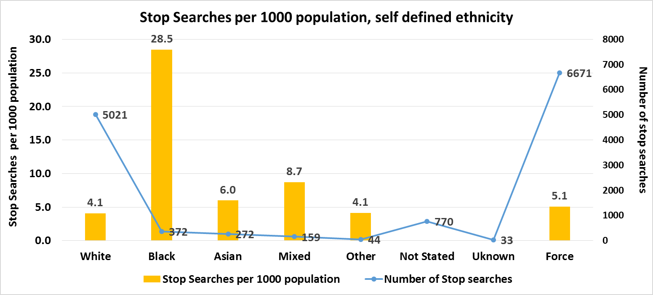

Figure 8a Stop Searches per 1000 population, 2016/17
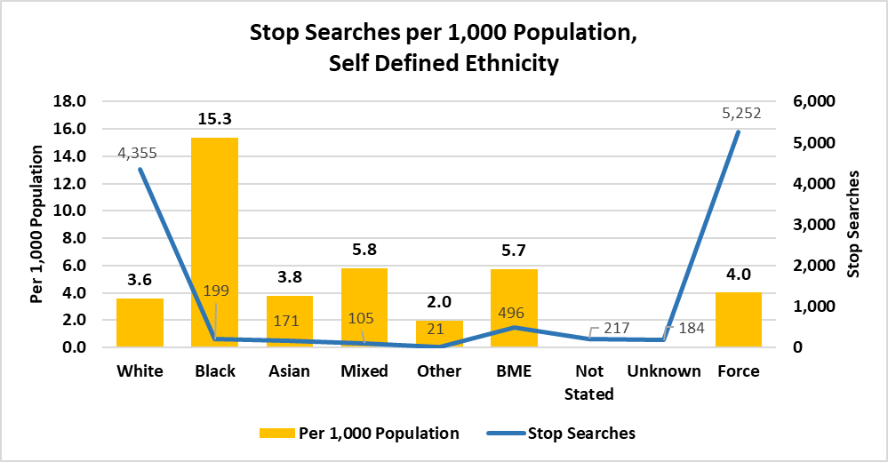

If we compare the last 3 years, you are more likely in 2018/19 to be stop searched if you are of Black ethnicity compared to any other year (from 15 people to 40 in every 1000 Black people in South Wales).

Figure 9 Outcomes by Ethnicity

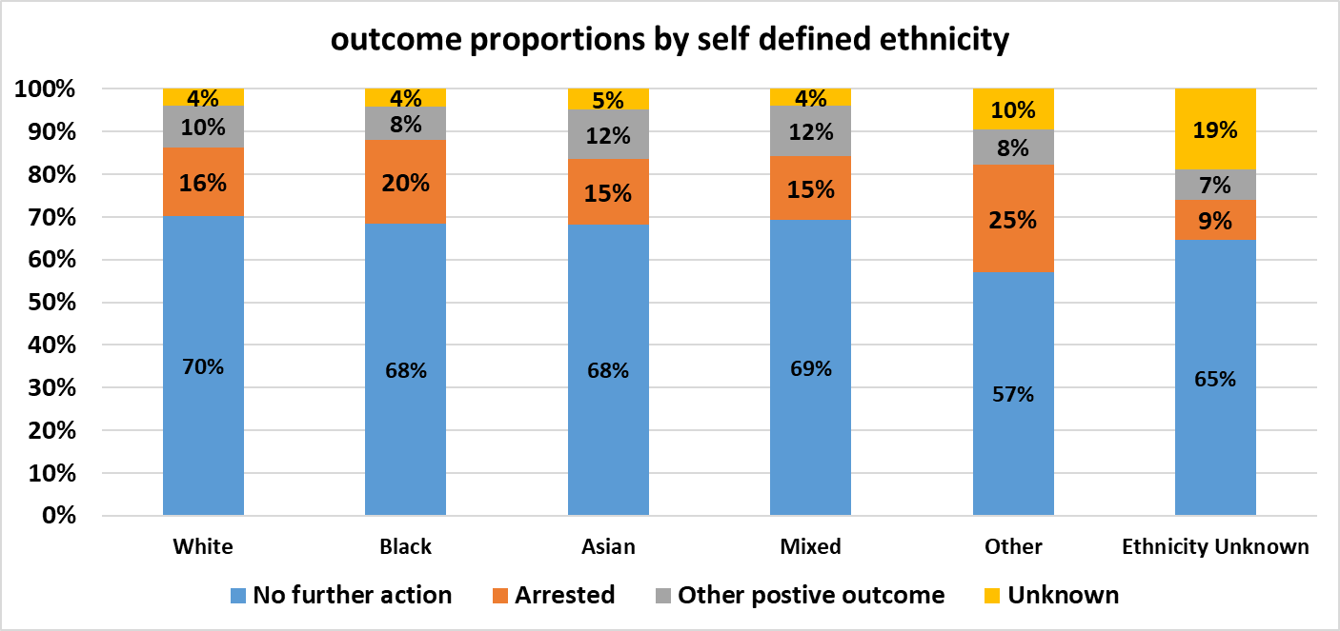

4.3 Stop Searches – Disproportionality by local authority

At force level, a BME member of the public is over twice as likely to be stop and searched as a white person. That said, when broken down to ethnicity and Local Authority, this comparison varies massively, although small numbers will have a strong influence.

Figure 10a below, shows the number of stop searches per 1,000 population by ethnicity and local authority.

Figure 10a Stop Searches per 1,000 population by local authority

Local Authority | All Searches | White | BME | Black | Asian | Mixed | Other
Merthyr Tydfil | 3.93 | 3.72 | 1.39 | 6.85 | 0.00 | 2.12 | 0.00
Rhondda Cynon Taf | 5.14 | 4.82 | 3.53 | 3.82 | 1.31 | 6.54 | 9.23
Cardiff | 11.24 | 8.31 | 15.42 | 43.64 | 9.16 | 15.48 | 6.46
Vale of Glamorgan | 2.64 | 2.19 | 4.37 | 10.02 | 3.00 | 4.64 | 2.83
Bridgend | 4.01 | 3.71 | 5.60 | 33.54 | 2.48 | 0.96 | 8.47
Neath Port Talbot | 3.19 | 2.96 | 9.03 | 23.03 | 3.59 | 8.67 | 32.89
Swansea | 5.99 | 5.36 | 8.81 | 28.25 | 5.91 | 6.77 | 4.03
South Wales | 6.34 | 5.13 | 12.16 | 35.14 | 7.27 | 11.19 | 6.22

The Cardiff local authority has the bulk of stop searches, whether it is searches in total, or searches of BME persons – but it also has a 15% BME population. That said, Cardiff do still have a stop search rate of 43.64 per 1,000 black population.

We can also express disproportionality as a ratio of the number of stop searches against each ethnicity compared to one white stop search in that area. Figure 10b, shows that even though Cardiff has the highest black stop search rate, this is not equivalent to the highest relative stop search rate with a black person being 5.25 times as likely to be stop searched compared to a white person. A black person in Bridgend is approximately 9 times more likely to be searched than a white person, although this has to be judged in the context of both the low black population within the local authority area, but also the low total number of stop searches conducted in that area. 11 black stop searches were conducted in Bridgend, against an estimated black population of 328, with only 574 stop searches conducted for all ethnicities.

Figure 10b Comparing the likelihood of being stop searched with that for a white person
(1.00 = same likelihood of being stop searched)

Comparative Rate against  White Searches | BME | Black | Asian | Mixed | Other
Merthyr Tydfil | 0.37 | 1.84 | 0.00 | 0.57 | 0.00
Rhondda Cynon Taf | 0.73 | 0.79 | 0.27 | 1.36 | 1.92
Cardiff | 1.86 | 5.25 | 1.10 | 1.86 | 0.78
Vale of Glamorgan | 2.00 | 4.58 | 1.37 | 2.12 | 1.29
Bridgend | 1.51 | 9.04 | 0.67 | 0.26 | 2.29
Neath Port Talbot | 3.05 | 7.78 | 1.21 | 2.93 | 11.11
Swansea | 1.65 | 5.27 | 1.10 | 1.26 | 0.75
South Wales | 2.37 | 6.85 | 1.42 | 2.18 | 1.21

It should be noted however, that there is a slight difference between the figures for searches within Local Authorities compared to for all of South Wales, due to the number of searches with no valid postcode. Figure 10c gives the actual numbers of stop searches for those with valid postcode:
Figure 10c Comparisons of 2018-19 stop search volumes by ethnicity

Local Authority | All Searches | White Searches | BME Searches | Black Searches | Asian Searches | Mixed Searches | Other Searches | Not Stated / Unknown
Merthyr Tydfil | 235 | 217 | 2 | 1 | 0 | 1 | 0 | 16
Rhondda Cynon Taf | 1,224 | 1,118 | 22 | 5 | 4 | 10 | 3 | 84
Cardiff | 4,063 | 2,534 | 874 | 390 | 272 | 164 | 48 | 655
Vale of Glamorgan | 339 | 271 | 20 | 5 | 6 | 8 | 1 | 48
Bridgend | 574 | 519 | 18 | 11 | 4 | 1 | 2 | 37
Neath Port Talbot | 451 | 411 | 25 | 7 | 5 | 8 | 5 | 15
Swansea | 1,465 | 1,230 | 131 | 58 | 48 | 15 | 10 | 104
South Wales | 8,351 | 6,300 | 1,092 | 477 | 339 | 207 | 69 | 959

4.4 Stop Searches and Age Groups
The majority of stop searches (72%) were associated with individuals aged under 35 with 19% of all stop searches relating to persons aged 17 and below, as figure 11 shows.

Figure 11 Stop Searches by Age Group
 | Volume |  |  |  | proportion
Age Group | NORTHERN | EASTERN | CENTRAL | WESTERN | NORTHERN | EASTERN | CENTRAL | WESTERN
7 to 17 | 377 | 840 | 238 | 341 | 17.2% | 21.6% | 20.7% | 16.0%
18 to 34 | 1201 | 2045 | 612 | 1098 | 54.6% | 52.6% | 53.1% | 51.6%
35 to 44 | 398 | 652 | 174 | 458 | 18.1% | 16.8% | 15.1% | 21.5%
45 to 64 | 170 | 261 | 101 | 197 | 7.7% | 6.7% | 8.8% | 9.3%
65 plus | 2 | 4 | 4 | 4 | 0.1% | 0.1% | 0.3% | 0.2%
Unknown | 50 | 85 | 23 | 28 | 2.3% | 2.2% | 2.0% | 1.3%
Total | 2198 | 3887 | 1152 | 2126 | 100.0% | 100.0% | 100.0% | 100.0%

4.5 Stop Searches and Purpose of Search
Drugs remains the most common purpose for searching people representing 56% of the force’s activity: the highest proportion was in Central BCU where it accounted for 66% of all searches and the lowest was in Northern BCU contributing to 53% of all searches.

Figure 12 Stop Searches by Officer BCU and Purpose
Search reason | NORTHERN | EASTERN | CENTRAL | WESTERN | SPEC OPS | JFU | K Div | Unknown | ALL
Drugs | 1179 | 2104 | 765 | 1350 | 419 | 54 | 32 | 64 | 5967
Articles for use in theft | 238 | 412 | 76 | 186 | 45 | 20 | 5 | 4 | 986
Bladed article | 101 | 282 | 93 | 127 | 51 | 62 | 5 | 7 | 728
Stolen goods | 157 | 277 | 42 | 146 | 38 | 18 | 9 | 7 | 694
Unknown | 149 | 143 | 93 | 73 | 55 | 36 | 8 | 21 | 578
Going equipped | 146 | 207 | 20 | 76 | 43 | 7 | 5 |  | 504
Offensive weapons | 50 | 127 | 31 | 32 | 36 | 27 |  | 2 | 305
Evidence of offences under the act | 35 | 85 | 7 | 32 | 12 | 3 | 3 |  | 177
Articles for use in criminal damage | 41 | 69 | 7 | 27 | 4 | 4 | 1 |  | 153
Anything to threaten or harm anyone | 17 | 37 | 6 | 34 | 13 | 11 |  |  | 118
Other | 32 | 47 | 5 | 23 | 9 | 2 |  |  | 118
Firearms | 8 | 15 | 2 | 10 | 6 | 24 |  | 1 | 66
Criminal damage | 13 | 29 | 1 | 3 | 4 | 3 | 1 | 1 | 55
Fireworks | 8 | 34 | 1 |  | 2 |  |  |  | 45
Sus crime/disorder/ASB | 6 | 4 | 2 |  |  |  |  |  | 12
Public order | 6 | 3 |  | 1 |  |  |  |  | 10
Intoxicating liquor | 7 |  |  | 1 |  | 1 |  |  | 9
Warrant/bail check | 1 | 4 |  | 1 | 1 |  |  |  | 7
Traffic related |  | 3 |  | 2 | 1 |  |  |  | 6
Goods - duty not paid, etc. | 1 | 2 |  |  |  | 1 |  |  | 4
Terrorism |  | 1 |  |  | 1 | 1 |  |  | 3
Psychoactive substances | 2 |  |  | 1 |  |  |  |  | 3
Seizure of alcohol or tobacco |  |  |  | 1 | 2 |  |  |  | 3
Aerodrome related offence |  | 2 |  |  |  |  |  |  | 2
Game or poaching equipment | 1 |  |  |  |  |  |  |  | 1
Crossbows |  |  | 1 |  |  |  |  |  | 1
Total | 2198 | 3887 | 1152 | 2126 | 742 | 274 | 69 | 107 | 10555

Please see the below table which shows both the volume and the percentage of stop searches conducted by the reason of the search and by ethnicity:
Search Reason | White | Black | Asian | Mixed | Other | Unknown | All
Drugs | 4604 | 371 | 283 | 156 | 39 | 514 | 5967
Articles for use in theft | 823 | 26 | 16 | 19 | 10 | 92 | 986
Bladed article | 555 | 43 | 23 | 21 | 6 | 80 | 728
Stolen goods | 589 | 17 | 20 | 13 | 9 | 46 | 694
Unknown | 310 | 23 | 17 | 9 | 7 | 212 | 578
Going equipped | 423 | 14 | 11 | 6 | 3 | 47 | 504
Offensive weapons | 228 | 18 | 16 | 12 | 1 | 30 | 305
Evidence of offences under the act | 140 | 8 | 6 | 3 |  | 20 | 177
Articles for use in criminal damage | 124 | 4 | 2 | 1 | 1 | 21 | 153
Anything to threaten or harm anyone | 89 | 4 | 5 | 3 | 5 | 12 | 118
Other | 93 | 4 |  | 5 | 1 | 15 | 118
Firearms | 53 | 1 | 4 | 2 |  | 6 | 66
Criminal damage | 44 |  | 2 | 2 | 1 | 6 | 55
Fireworks | 23 | 2 | 1 | 2 | 1 | 16 | 45
Sus crime/disorder/ASB | 10 |  |  |  |  | 2 | 12
Public order | 10 |  |  |  |  |  | 10
Intoxicating liquor | 9 |  |  |  |  |  | 9
Warrant/bail check | 7 |  |  |  |  |  | 7
Traffic related | 4 | 1 | 1 |  |  |  | 6
Goods - duty not paid, etc. | 4 |  |  |  |  |  | 4
Terrorism | 3 |  |  |  |  |  | 3
Psychoactive substances | 3 |  |  |  |  |  | 3
Seizure of alcohol or tobacco | 3 |  |  |  |  |  | 3
Aerodrome related offence | 2 |  |  |  |  |  | 2
Game or poaching equipment | 1 |  |  |  |  |  | 1
Crossbows | 1 |  |  |  |  |  | 1
Total | 8155 | 536 | 407 | 254 | 84 | 1119 | 10555
Search Reason | White | Black | Asian | Mixed | Other | Unknown | All Ethnicities
Drugs | 56.5% | 69.2% | 69.5% | 61.4% | 46.4% | 45.9% | 56.5%
Articles for use in theft | 10.1% | 4.9% | 3.9% | 7.5% | 11.9% | 8.2% | 9.3%
Bladed article | 6.8% | 8.0% | 5.7% | 8.3% | 7.1% | 7.1% | 6.9%
Stolen goods | 7.2% | 3.2% | 4.9% | 5.1% | 10.7% | 4.1% | 6.6%
Unknown | 3.8% | 4.3% | 4.2% | 3.5% | 8.3% | 18.9% | 5.5%
Going equipped | 5.2% | 2.6% | 2.7% | 2.4% | 3.6% | 4.2% | 4.8%
Offensive weapons | 2.8% | 3.4% | 3.9% | 4.7% | 1.2% | 2.7% | 2.9%
Evidence of offences under the act | 1.7% | 1.5% | 1.5% | 1.2% | 0.0% | 1.8% | 1.7%
Articles for use in criminal damage | 1.5% | 0.7% | 0.5% | 0.4% | 1.2% | 1.9% | 1.4%
Anything to threaten or harm anyone | 1.1% | 0.7% | 1.2% | 1.2% | 6.0% | 1.1% | 1.1%
Other | 1.1% | 0.7% | 0.0% | 2.0% | 1.2% | 1.3% | 1.1%
Firearms | 0.6% | 0.2% | 1.0% | 0.8% | 0.0% | 0.5% | 0.6%
Criminal damage | 0.5% | 0.0% | 0.5% | 0.8% | 1.2% | 0.5% | 0.5%
Fireworks | 0.3% | 0.4% | 0.2% | 0.8% | 1.2% | 1.4% | 0.4%
Sus crime/disorder/ASB | 0.1% | 0.0% | 0.0% | 0.0% | 0.0% | 0.2% | 0.1%
Public order | 0.1% | 0.0% | 0.0% | 0.0% | 0.0% | 0.0% | 0.1%
Intoxicating liquor | 0.1% | 0.0% | 0.0% | 0.0% | 0.0% | 0.0% | 0.1%
Warrant/bail check | 0.1% | 0.0% | 0.0% | 0.0% | 0.0% | 0.0% | 0.1%
Traffic related | 0.0% | 0.2% | 0.2% | 0.0% | 0.0% | 0.0% | 0.1%
Goods - duty not paid, etc. | 0.0% | 0.0% | 0.0% | 0.0% | 0.0% | 0.0% | 0.0%
Terrorism | 0.0% | 0.0% | 0.0% | 0.0% | 0.0% | 0.0% | 0.0%
Psychoactive substances | 0.0% | 0.0% | 0.0% | 0.0% | 0.0% | 0.0% | 0.0%
Seizure of alcohol or tobacco | 0.0% | 0.0% | 0.0% | 0.0% | 0.0% | 0.0% | 0.0%
Aerodrome related offence | 0.0% | 0.0% | 0.0% | 0.0% | 0.0% | 0.0% | 0.0%
Game or poaching equipment | 0.0% | 0.0% | 0.0% | 0.0% | 0.0% | 0.0% | 0.0%
Crossbows | 0.0% | 0.0% | 0.0% | 0.0% | 0.0% | 0.0% | 0.0%
Total | 100.0% | 100.0% | 100.0% | 100.0% | 100.0% | 100.0% | 100.0%

For all ethnic groups the search reason being “Drugs” accounted for the majority of stop searches, more so if you were of Black/ Asian ethnicity (accounting for nearly 70%). The second most common reason why people were stop searched was “Article for use in theft”. If you were of white ethnicity, you were more likely to be searched for this reason.
The below table shows the types of outcomes by BCU:
SDE | No further action | Arrest | Other positive outcomes | Unknown | All Outcomes
white | 5734 | 1307 | 787 | 327 | 8155
Black | 367 | 105 | 42 | 22 | 536
Asian | 278 | 62 | 47 | 20 | 407
mixed | 176 | 38 | 30 | 10 | 254
Other | 48 | 21 | 7 | 8 | 84
Unknown | 724 | 105 | 78 | 212 | 1119
All Ethnicities | 7327 | 1638 | 991 | 599 | 10555

The table below shows the types of outcomes by Self-defined ethnicity (Volume and percentage):
SDE | No further action | Arrest | Other positive outcomes | Unknown | All Outcomes
white | 5734 | 1307 | 787 | 327 | 8155
Black | 367 | 105 | 42 | 22 | 536
Asian | 278 | 62 | 47 | 20 | 407
mixed | 176 | 38 | 30 | 10 | 254
Other | 48 | 21 | 7 | 8 | 84
unknown | 724 | 105 | 78 | 212 | 1119
All Ethnicities | 7327 | 1638 | 991 | 599 | 10555
SDE | No further action | Arrest | Other positive outcomes | Unknown | All Outcomes
White | 78% | 80% | 79% | 55% | 77%
Black | 5% | 6% | 4% | 4% | 5%
Asian | 4% | 4% | 5% | 3% | 4%
Mixed | 2% | 2% | 3% | 2% | 2%
Other | 1% | 1% | 1% | 1% | 1%
Unknown | 10% | 6% | 8% | 35% | 11%
All Ethnicities | 100% | 100% | 100% | 100% | 100%

4.5 Stop Searches –Relationship of Search Reason to the Outcome
The charts below show that only 15% of stop searches result in an outcome that is directly linked to the purpose of the Search. Central and Western BCU had 18% of their stop searches resulting in outcomes linked to the purpose of the stop search however, in Northern and Eastern BCU only 14% to 15% of stop searches had outcomes linked to the purpose.

For all positive outcomes (arrest, penalty notices, drug warnings, caution, summons), the largest proportion of these outcomes linked to purpose was in Central at 67% of all positive outcomes and the smallest proportion was for Eastern BCU at 53% of all positive outcomes.

Figure 13 Relationship between Purpose and Outcome by BCU and Outcome Type 2018/19
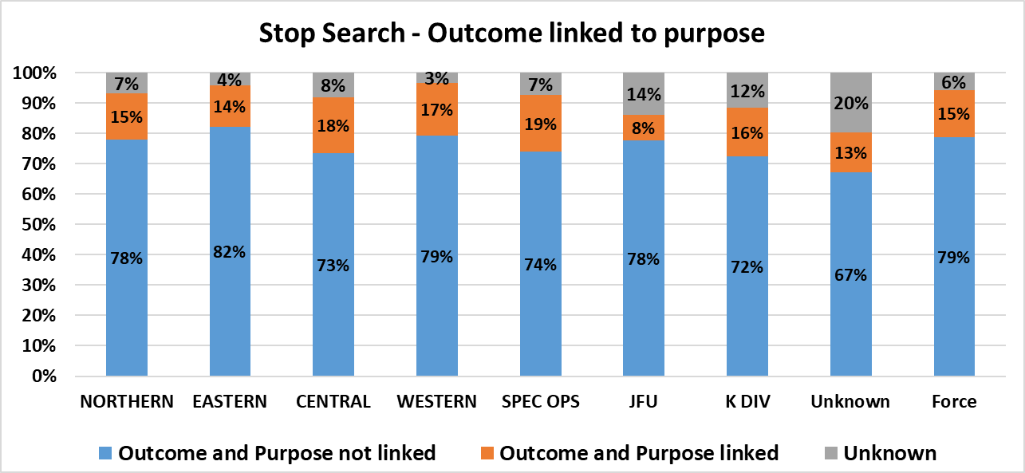

The following charts display the above but for the last 2 financial years to be able to make some comparisons:

Figure 13a Relationship between Purpose and Outcome by BCU and Outcome Type 2017/18
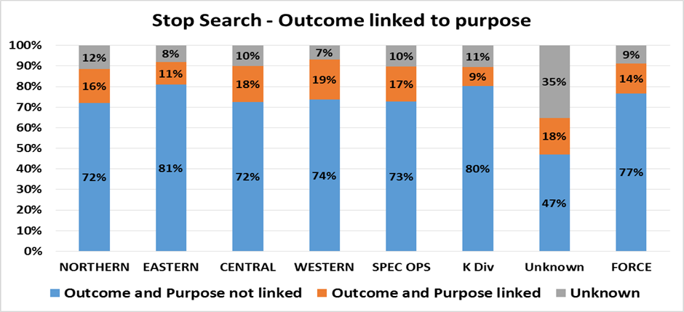

Figure 13a Relationship between Purpose and Outcome by BCU and Outcome Type 2016/17
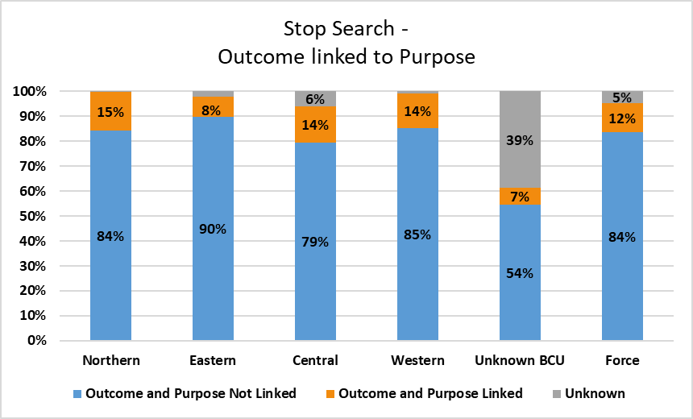
Overall, in the last financial year we have seen at a Force level a higher percentage of stop searches whereby the search reason was linked to the outcome of the search.
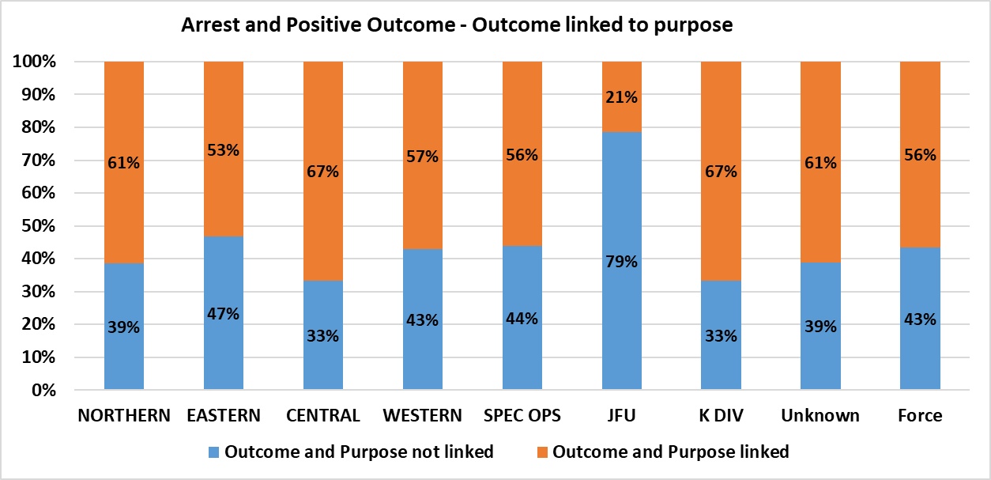
We can also analyse the relationship of the outcome being linked to the purpose of a search by Ethnicity. In 2018/19, if you were of Asian ethnicity, a high proportion of searches (20.1%) resulted in the outcome being linked to the purpose. If you were of Black ethnicity, you were only slightly more likely to have the outcome of the search linked to the reason compared to those of white ethnicity.

Figure 14 Relationship between Purpose and Outcome by self-defined ethnicity (SDE)
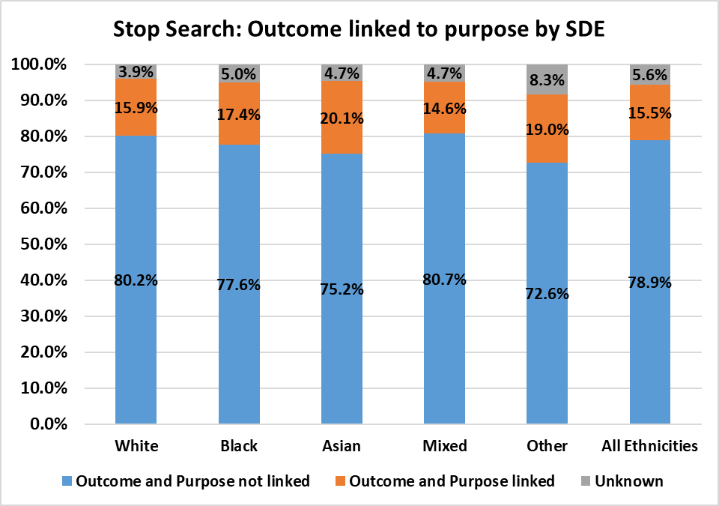

4.6 Stop Searches – Body worn video
When officers are completing a stop search, it is mandatory that a body worn camera is used. We are unaware of the exact date from when the BCUs had access to the equipment but we do know that it has been a gradual phasing in approach with training etc during financial year 2017/18. Therefore, 2018/19 year to date is a good indicator of true compliance, as body worn video should now be embedded within police culture. As you can see from the below table, compliance has significantly increased month on month with it levelling off now.

Month | BWC Used | BWC Not used | All Stop Searches | Percentage BWC Used
2018/04 | 517 | 270 | 787 | 66%
2018/05 | 572 | 236 | 808 | 71%
2018/06 | 663 | 204 | 867 | 76%
2018/07 | 639 | 216 | 855 | 75%
2018/08 | 669 | 175 | 844 | 79%
2018/09 | 648 | 165 | 813 | 80%
2018/10 | 902 | 309 | 1211 | 74%
2018/11 | 680 | 207 | 887 | 77%
2018/12 | 596 | 210 | 806 | 74%
2019/01 | 730 | 182 | 912 | 80%
2019/02 | 585 | 178 | 763 | 77%
2019/03 | 748 | 181 | 929 | 81%

